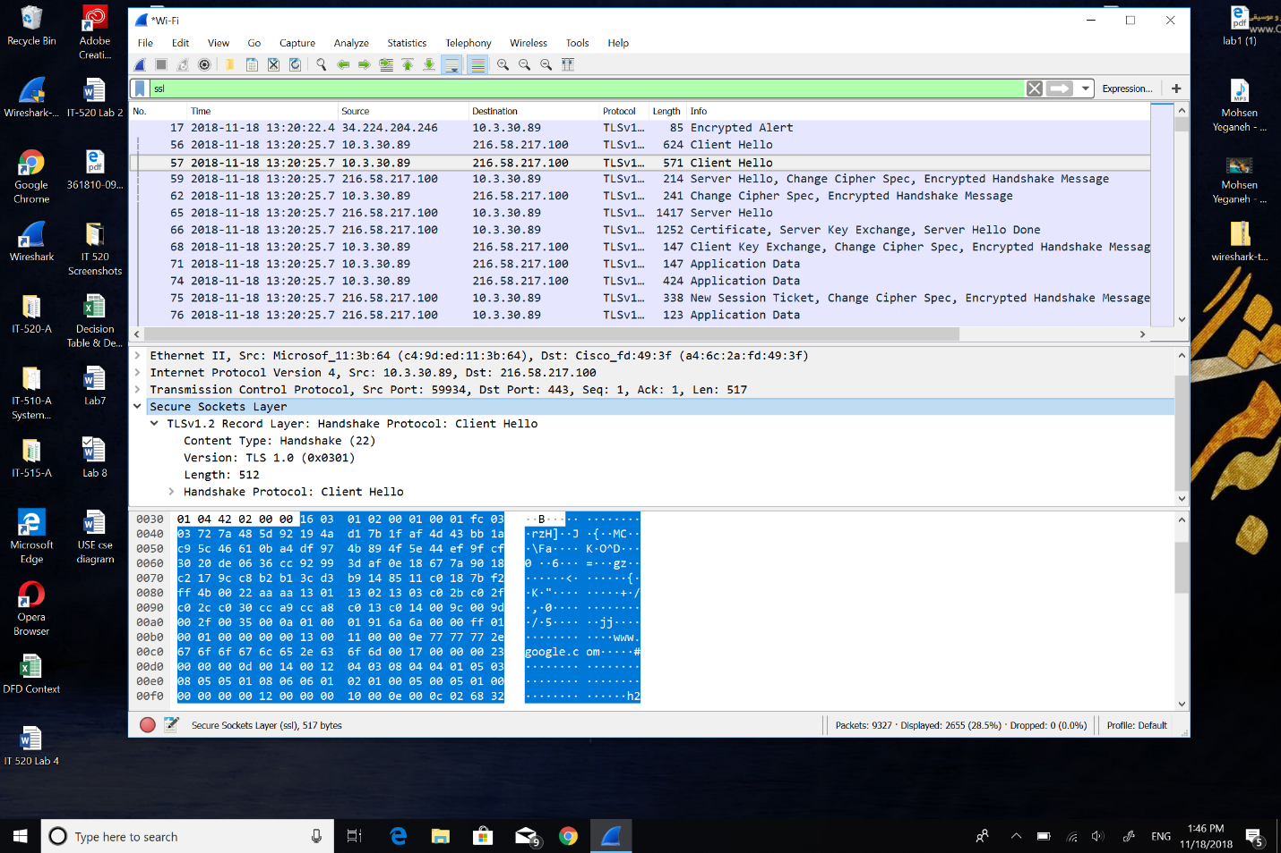1: The SSL/TLS version of the of the Client Hello frame is TLS version 1.0.



2: The value of the content type in Handshake (22).

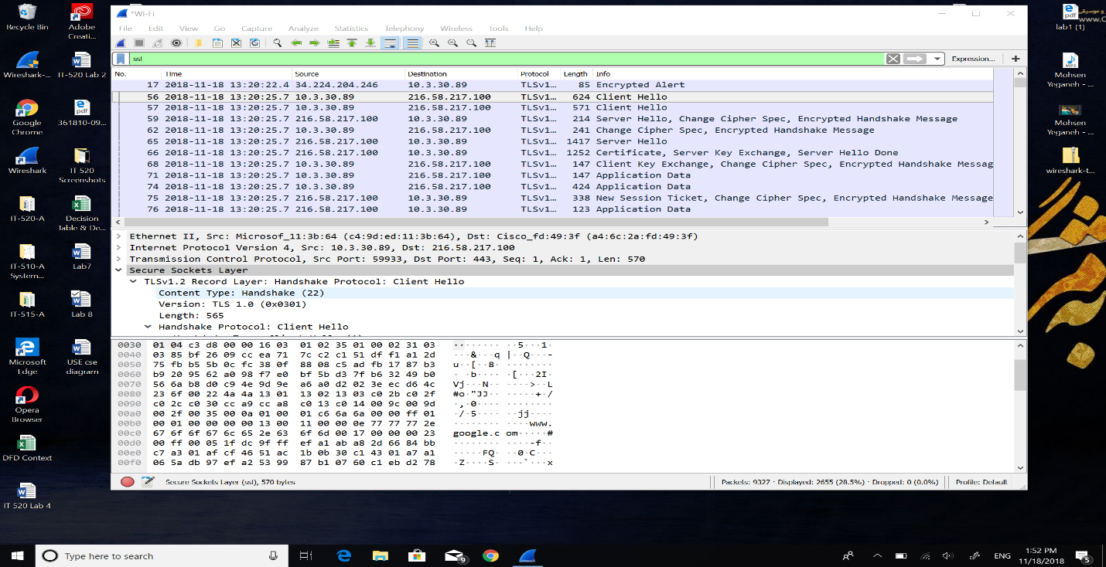



3: My ClientHello record doesn’t contain a nonce, I tried multiple times but couldn’t get and noce nor challenge. 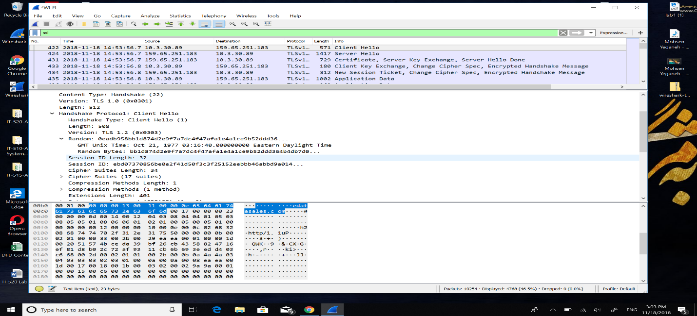



4: Yes, Public key algorithm: AES

Symmetric‐key algorithm: GCM

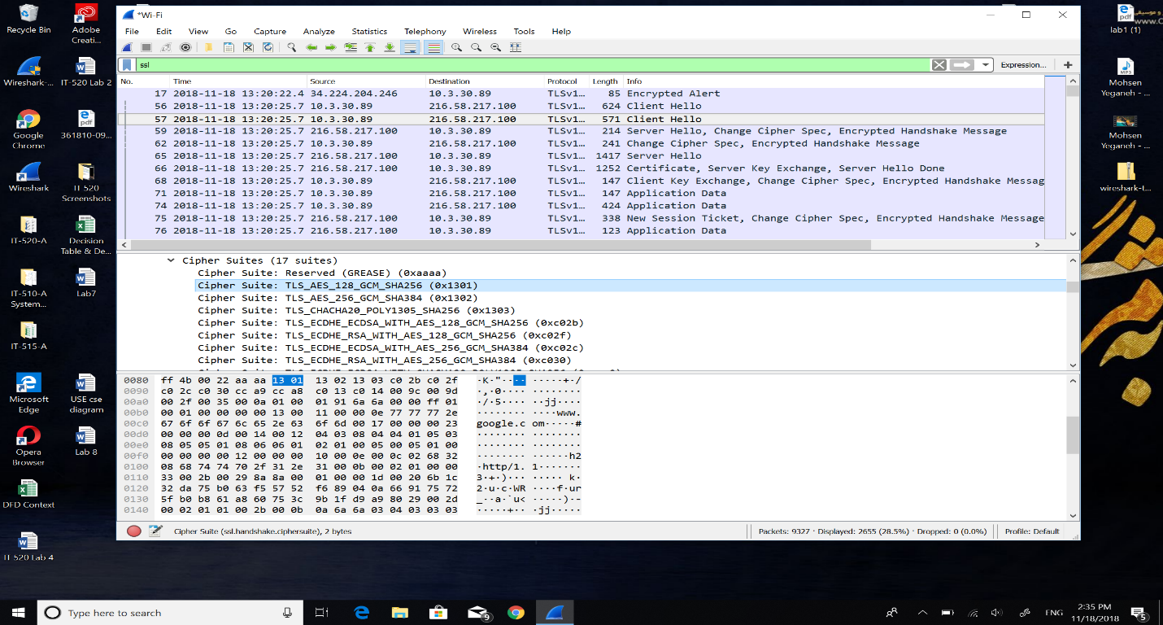RC4 Hash algorithm: SHA



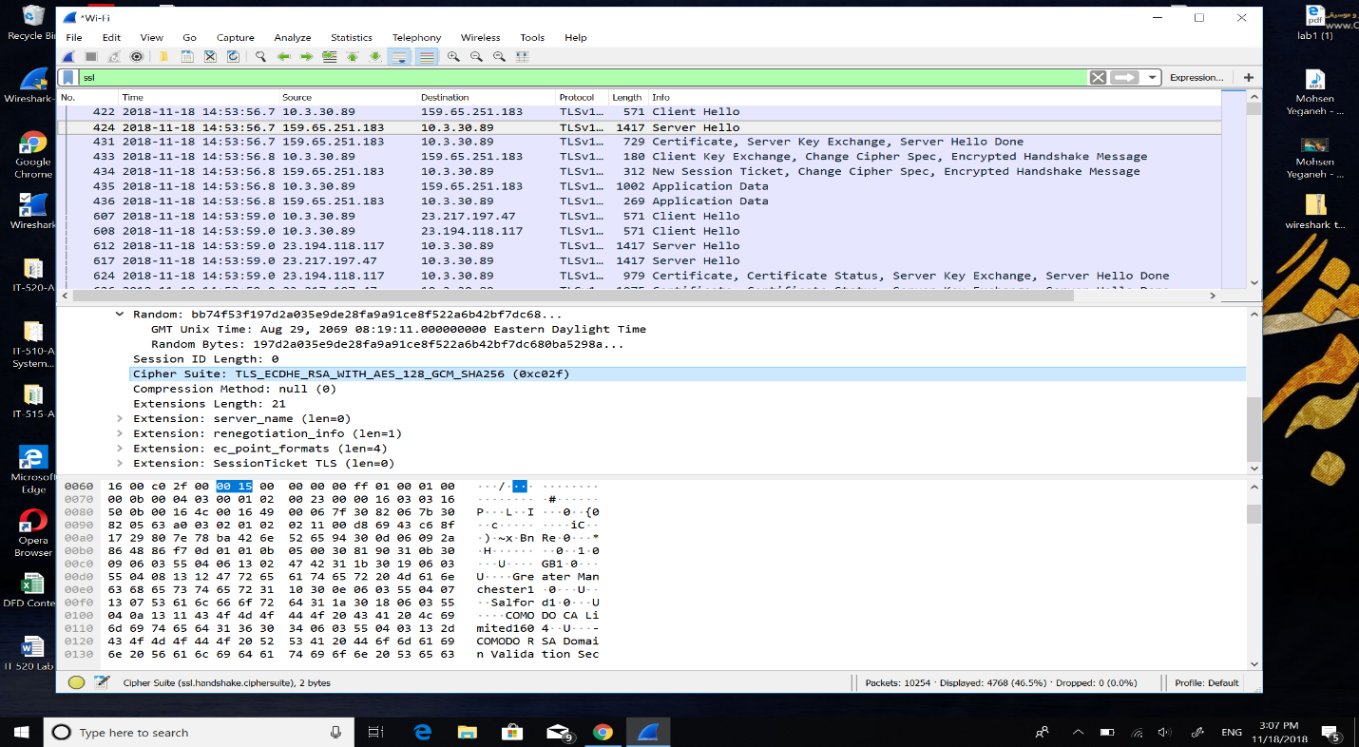5: In the server hello the algorithms are AES, GCM, SHA.